**Homework 1**

**HW 1-1 Simulate a Function**

Describe the models you use, including the number of parameters (at least two models) and the function you use.   
GitHub link: [Deep-Learning/HW1 simulate function.ipynb at master · nik1097/Deep-Learning (github.com)](https://github.com/nik1097/Deep-Learning/blob/master/Homework%201/HW1%20simulate%20function.ipynb)

Models: I have defined 3 models that are the same as the ones shared in the requirements. A weight decay parameter has been added to regularize the models better by adding a penalty term to the cost function of a neural network which has the effect of shrinking the weights during backpropagation.

* Model 1:
  + 7 Dense Layers, 571 parameters
  + Loss Function: MSELoss
  + Optimizer: RMSProp
  + Learning Rate: 1e-3
  + Activation Function: LeakyRelu
  + Weight decay: 1e-4
* Model 2:
  + 4 Dense Layers, 572 parameters
  + Loss Function: MSELoss
  + Optimizer: RMSProp
  + Learning Rate: 1e-3
  + Activation Function: LeakyRelu
  + Weight decay: 1e-4
* Model 3:
  + 1 Dense Layer, 571 parameters
  + Loss Function: MSELoss
  + Optimizer: RMSProp
  + Learning Rate: 1e-3
  + Activation Function: LeakyRelu
  + Weight decay: 1e-4

Function 1  
Function: sin(5*pi*x) / 5*pi*x  
Below is the function plot for the same function:

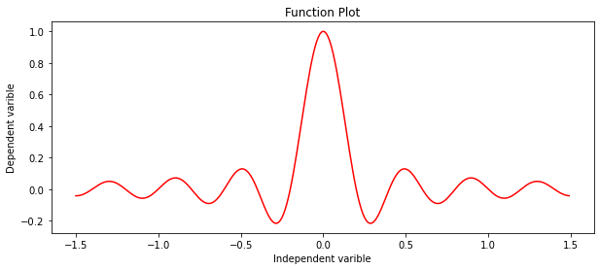

Simulating the Function:  
All models converge after reaching maximum number of epochs or when the model learns very slowly. Below is a graph showing the loss each of these models:

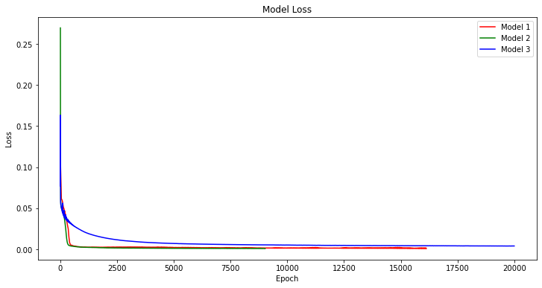

The graph below shows the Ground Truth vs the Prediction for the 3 models.

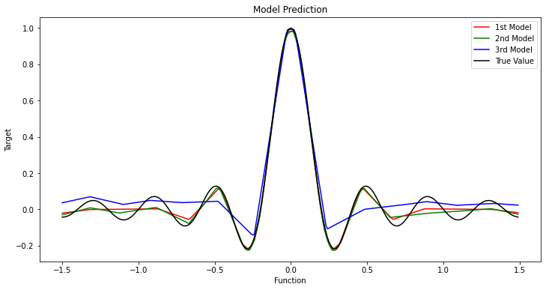

Result  
Models 1 & 2 converge quickly compared to model 3 which reaches maximum epochs before convergence. As denoted by the graph Models 1 & 2 have a lower loss value and learn the function much better than Model 3. This is a testament to the number of layers that each model possessed allowing the ones with more layers to learn faster and better.

Function 2  
Function: sgn(sin(5*pi*x) / 5*pi*x)  
Below is the function plot for the same function:

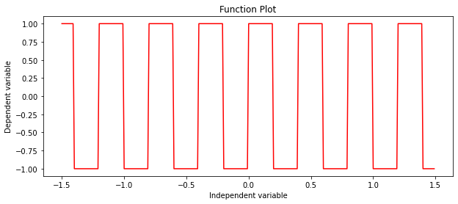

Simulating the Function:  
All models converge after reaching maximum number of epochs or when the model learns very slowly. Below is a graph showing the loss each of these models:

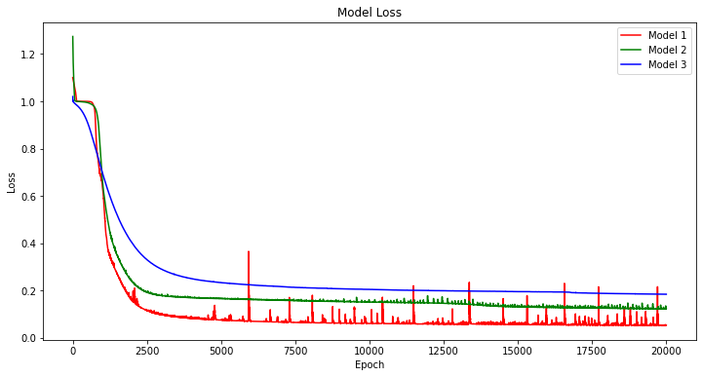

The graph below shows the Ground Truth vs the Prediction for the 3 models.

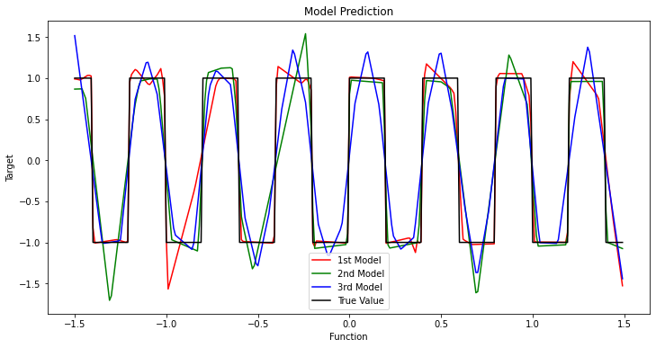

Result  
All the models reach the maximum number of epochs before convergence as the function is difficult to learn for the 3 models. Model 1 has the lowest loss and seems to be the best learner, marginally outperforming model 2. Model 3 fails to reduce reach a low loss and fails to converge over the range of epochs. This is again testament to the fact that a neural network with more layers tends to learn better and converge quicker.

**HW 1-1 Train on Actual Tasks**GitHub link: [Deep-Learning/Hw1 comMNIST.ipynb at master · nik1097/Deep-Learning (github.com)](https://github.com/nik1097/Deep-Learning/blob/master/Homework%201/Hw1%20comMNIST.ipynb)

The below models are trained on the MNIST dataset.   
Training Set: 60,000 Testing set: 10,000

Model 1: CNN (LeNet)

* 2D convolution layer: apply a 2D max pooling -> ReLu
* 2D convolution layer: apply a 2D max pooling -> ReLu
* 2D Dense Layer: ReLu
* 2D Dense Layer: ReLu

Model 2: CNN (custom)

* 2D convolution layer: ReLu
* 2D convolution layer: apply a 2D max pooling -> ReLu -> Dropout
* 2D convolution layer: apply a 2D max pooling -> ReLu -> Dropout
* 2D Dense Layer: ReLu -> Dropout
* 2D Dense Layer: Log_softmax (Output)

Hyperparameters

* Learning Rate: 0.01
* Momentum: 0.5
* Optimizer: Stochastic Gradient Descent
* batch_size = 64
* epochs = 10
* Loss: Cross Entropy

Below is the training loss for Model 1 and Model 2

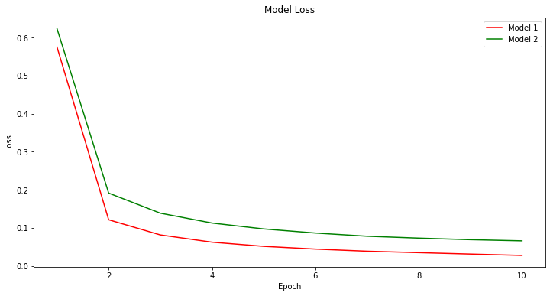

Below is the training accuracy for Model 1 and Model 2

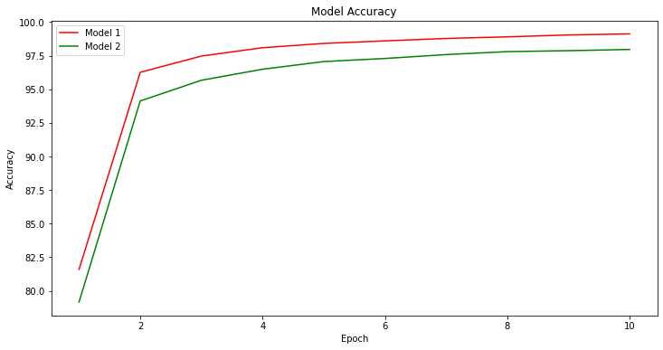

Result  
The Model 1 has a lower Loss and performs better than Model 2, the structure of Model 1 is an optimized CNN model based on the existing LeNet structure. It greatly outperforms the custom CNN model that has been built over the range of epochs. Intuitively a similar trend can be also observed with the accuracy as the model 1 outperforms model 2 with a higher training accuracy.

**HW 1-2 Visualize the optimization process**GitHub Link:[Deep-Learning/HW1 PCA.ipynb at master · nik1097/Deep-Learning (github.com)](https://github.com/nik1097/Deep-Learning/blob/master/Homework%201/HW1%20PCA.ipynb)

Collect the weights every 3 epochs, and train 8 times. Reduce the dimension of weights to 2 by   
PCA.

The below model is trained on the MNIST dataset.   
Training Set: 60,000 Testing set: 10,000

* 3 Dense Layers
* Loss Function: Cross Entropy Loss
* Optimizer: Adam
* Learning Rate: 0.0004
* Batch size: 1000
* Activation Function: ReLu

The collected weights are displayed in the above graph after the PCA algorithm has been applied on them. This shows reduction in the dimensions of the initial weights that were present. Initially we had 8240 parameters or weights for each model, after applying PCA on the models which were trained 8 times for 45 epochs we get the above graph.

**HW 1-2 Observe gradient norm during training**GitHub Link: [Deep-Learning/HW1 grad_norm.ipynb at master · nik1097/Deep-Learning (github.com)](https://github.com/nik1097/Deep-Learning/blob/master/Homework%201/HW1%20grad_norm.ipynb)

Thefunction sin(5*pi*x) / 5*pi*x has been reused to calculate the gradient norm and the loss. I have trained the model on epochs rather than iterations as the input to the model is already a small size.

Below is a graph for gradient norm across the epochs.

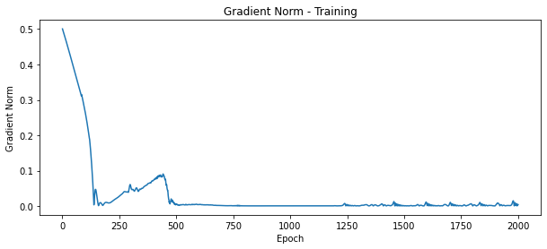

Below is a graph for loss across the epochs

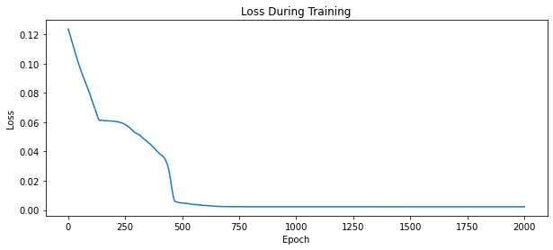

ResultThe model is trained and converged. There is a slight increase in the gradient after 100 epochs which is also observed with the loss in the other graph plateauing initially and decreasing at a lower rate before finally plateauing in the end after about 500 epochs.

**HW 1-3 Can network fit random labels?**GitHub Link: [Deep-Learning/HW1 rand_label_fit.ipynb at master · nik1097/Deep-Learning (github.com)](https://github.com/nik1097/Deep-Learning/blob/master/Homework%201/HW1%20rand_label_fit.ipynb)

The below model is trained on the MNIST dataset.   
Training Set: 60,000 Testing set: 10,000

Model 1: CNN (LeNet)

* 2D convolution layer: apply a 2D max pooling -> ReLu
* 2D convolution layer: apply a 2D max pooling -> ReLu
* 2D Dense Layer: ReLu
* 2D Dense Layer: ReLu

Hyperparameters

* Learning Rate: 0.0001
* Optimizer: Adam
* train_batch_size = 100
* test_batch_size = 100
* epochs = 100
* loss function: Cross Entropy Loss

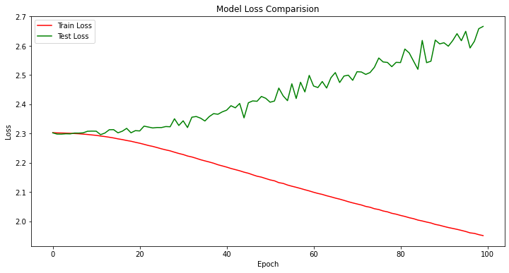

The above model is trained on random models. The training process is slow as the model must learn on random labels, it tries to memorize the labels as we move through epochs and reduce the loss. The test loss continues to increase as the epochs increase with a gradual decrease in the train loss. The above graph verifies the phenomenon and the gap between the Train and Test loss increases as we increase the number of epochs.

**HW 1-3 Number of parameters vs Generalization**GitHub Link: [Deep-Learning/HW1 param_compare.ipynb at master · nik1097/Deep-Learning (github.com)](https://github.com/nik1097/Deep-Learning/blob/master/Homework%201/HW1%20param_compare.ipynb)

The below model is trained on the MNIST dataset.   
Training Set: 60,000 Testing set: 10,000

* 3 Dense Layers
* Loss Function: Cross Entropy Loss
* Optimizer: Adam
* Learning Rate: 1e-3
* Batch size: 50
* Activation Function: ReLu

We vary the size of the models by approximately doubling the inputs and outputs at every dense layer, this increases the number of parameters for training.  
   
Graph for Loss comparison for the various models

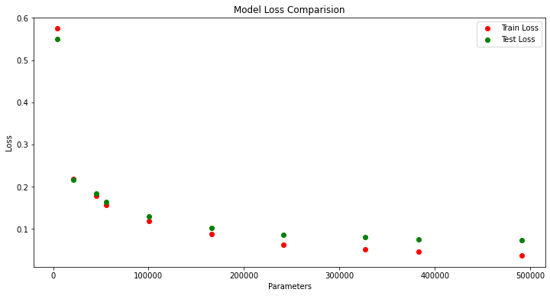

Graph for Accuracy comparison for the various models

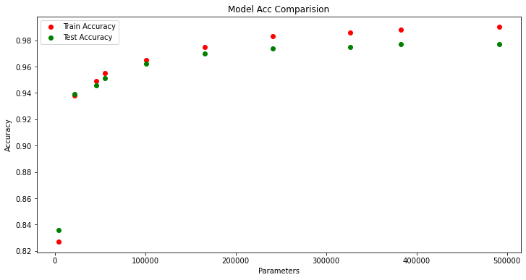

As it can be seen from the above graphs with increase in number of parameters the difference between the train and test loss/accuracy increases. The test loss starts plateauing much before the training loss or accuracy.   
This is due to overfitting as there are a greater number of parameters for the model to train. Although this increases the accuracy and decreases loss in training, we must aim to reduce the difference in between train and test loss/accuracy to avoid overfitting. Due to limitations in computing power, I was unable to further increase the number of parameters, but the trend can be inferred from the above graphs.

**HW 1-3 Flatness vs Generalization  
Part 1**GitHub Link: [Deep-Learning/HW1 Flat vs General interpolation.ipynb at master · nik1097/Deep-Learning (github.com)](https://github.com/nik1097/Deep-Learning/blob/master/Homework%201/HW1%20Flat%20vs%20General%20interpolation.ipynb)

The below model is trained on the MNIST dataset.   
Training Set: 60,000 Testing set: 10,000

* 3 Dense Layers, 2 convolution layers
* Loss Function: Cross Entropy Loss
* Optimizer: SGD
* Learning Rate: 1e-3, 1e -2
* Batch size: 100, 500
* Activation Function: ReLu
* Overview of Process  
  We train the models with varying batch sizes and collect their weights.
* We then use the formula “(1-alpha) * batch1_param + alpha * batch2_param” to calculate their interpolation ratio.
* We then create 50 models with the new values of weights that is substituted by the interpolation ratio.
* We then capture the new model’s loss and accuracy to plot them in a single graph that contains the loss and accuracy for both the models of varying batch size.

Learning Rate 1e-2

Learning Rate 1e-3

Observed Result  
We can see the accuracy of test and train drop around 1.5 for both the models with varying learning rate. The accuracy begins to increase steeply for the graphs at alpha value of 1.5. alpha is the interpolation ratio which is calculated by the formula. “(1-alpha) * batch1_param + alpha * batch2_param”.

We can conclude, all the machine learning algorithms [kind of interpolate](https://stats.stackexchange.com/a/529719/35989) between the datapoints, but if you have more parameters than data, will literally memorize the data and interpolate between them.

**Flatness vs Generalization – Part 2**GitHub Link:[Deep-Learning/HW1 Flat vs General_sensitivity.ipynb at master · nik1097/Deep-Learning (github.com)](https://github.com/nik1097/Deep-Learning/blob/master/Homework%201/HW1%20Flat%20vs%20General_sensitivity.ipynb)

The below model is trained on the MNIST dataset.   
Training Set: 60,000 Testing set: 10,000

* 3 Dense Layers, 2 convolution layers
* Loss Function: Cross Entropy Loss
* Optimizer: SGD
* Learning Rate: 1e-3
* Batch size: 50
* Activation Function: ReLu

* Note: In the graphs shown the legend is displayed incorrectly, the blue line refers to the sensitivity and the red/green lines refer to the model Accuracy and losses respectively.
* X -axis refers to batch size and the Y-axis for the graph on top refers to loss.
* Y-axis for the graph below refers to accuracy.

From the above graphs we can see that the sensitivity decreases with increase in batch size. The sensitivity peaks with an optimum batch size of around 4000 and then continues to reduce with drop in accuracy and increase in loss value. We can conclude that the network becomes less sensitive as the batch size increases beyond 5000 epochs.